Technical Documentation
How to use this template: Replace all bracketed placeholders like [Enter …] with your project’s values. If a section is not applicable, mark N/A and briefly explain why.

Technical Specifications
- Input Voltage Range: [12V]
- Maximum Current Consumption: [150–300mA]
- Power Consumption (Watts): [2.4 W.]
- Operating Frequency Range: 150 MHz
- Communication bus (e.g., RS-485): [10 Mbps]
- Operating Temperature Range: [–40 °C to +85 °C]
- Humidity Specifications: [5–95% RH]
- Vibration/Shock Specifications: [N/A]
- Ingress Protection (IP) Rating: [Enter IP rating or "Not IP-rated; requires enclosure"]
- Physical Dimensions and Weight: 42.926 X51.816X, N/A]
- RF/Radio Communication: ["No RF; wired bus only(RS-4850"]

Circuit Design Documentation
Attach files/links or paste summaries. Keep filenames and revision IDs.
- Complete schematic diagram with component references: [https://u.easyeda.com/join?type=project&key=74e25bc581c68dfe8ec05f6326f09f61&inviter=2127baaa7fef4d08914c588199b960e8]
- 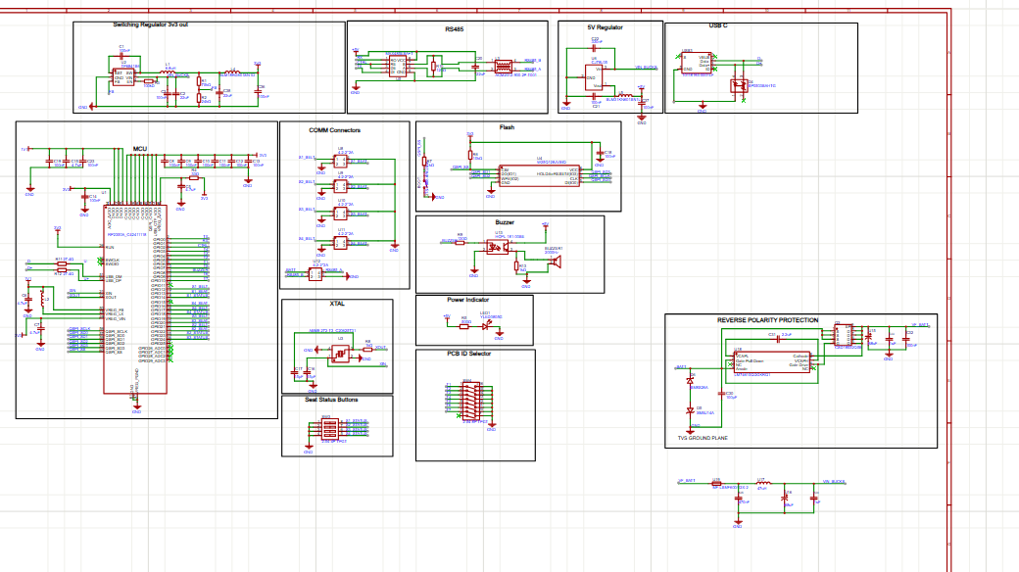
- PCB layout files (top and bottom layers): [https://u.easyeda.com/join?type=project&key=74e25bc581c68dfe8ec05f6326f09f61&inviter=2127baaa7fef4d08914c588199b960e8]

TOP LAYER
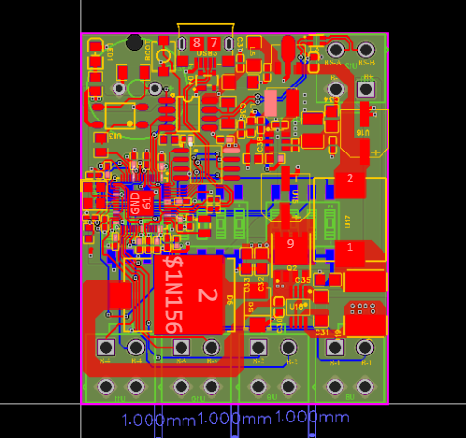
GND LAYER
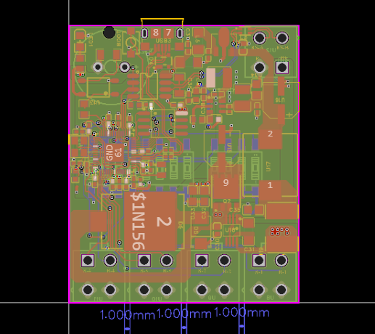
POWER LAYER
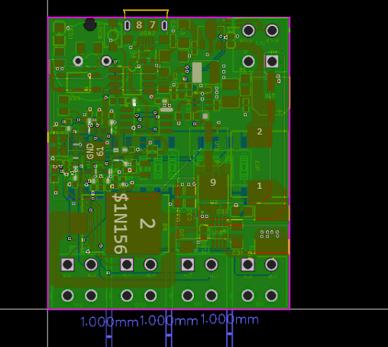
BOTTOM LAYER
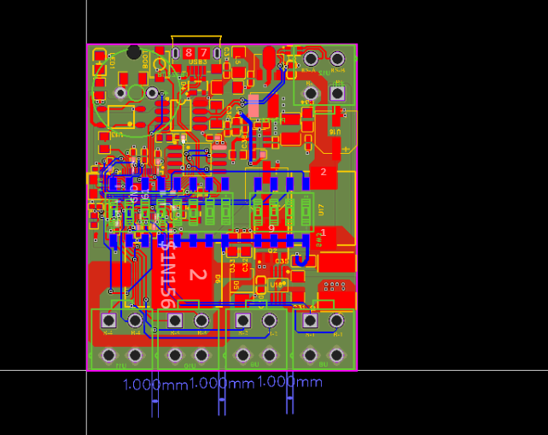

- Ground plane layout: [https://u.easyeda.com/join?type=project&key=74e25bc581c68dfe8ec05f6326f09f61&inviter=2127baaa7fef4d08914c588199b960e8]

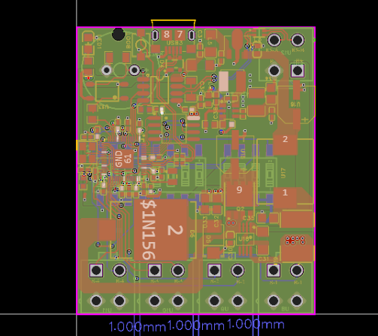
- Component placement drawings: [https://u.easyeda.com/join?type=project&key=74e25bc581c68dfe8ec05f6326f09f61&inviter=2127baaa7fef4d08914c588199b960e8]

TOP
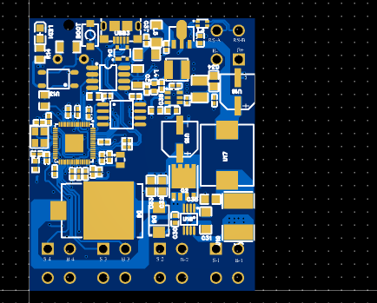
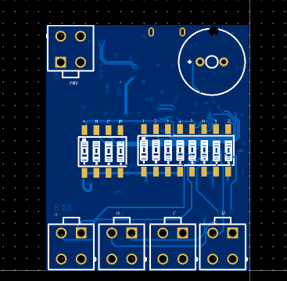
BOTTOM
- Wire routing diagrams: [https://u.easyeda.com/join?type=project&key=74e25bc581c68dfe8ec05f6326f09f61&inviter=2127baaa7fef4d08914c588199b960e8]
- Signal flow diagrams: [N/A]
- Block diagram of system architecture: [N/A]

Component Documentation

Bill of Materials (BOM)
https://docs.google.com/spreadsheets/d/1W86v9JCwA5cnLnYGioNLJq7QOEsg5wlAjquBIfHMDaE/edit?usp=sharing
No. | Manufacturer Part | Designator | Footprint | Quantity | Manufacturer Part | Manufacturer | Supplier | Supplier Part | JLCPCB Price | pinout
1 | TS-1088-AR02016 | BOOT | SW-SMD_L3.9-W3.0-P4.45 | 1 | TS-1088-AR02016 | XUNPU(讯普) | LCSC | C720477 | 0.0061
2 | PS1420P02CT | BUZZER1 | BUZ-TH_BD14.0-P5.00-D0.7-FD | 1 | PS1420P02CT | TDK | LCSC | C91080 | 0.0364
3 | CL05B104KO5NNNC | C1,C3,C21 | C0402 | 3 | CL05B104KO5NNNC | SAMSUNG(三星) | LCSC | C1525 | 0.0002
4 | CL32A226KOJNNNE | C2 | C1210 | 1 | CL32A226KOJNNNE | SAMSUNG(三星) | LCSC | C19659 | 0.0135
5 | CL05A475MP5NRNC | C5,C6,C7,C15 | C0402 | 4 | CL05A475MP5NRNC | SAMSUNG(三星) | LCSC | C23733 | 0.0007
6 | 0402B104K250NT | C8,C9,C10,C11,C12,C13,C14,C18,C19,C23,C36,C37 | C0402 | 12 | 0402B104K250NT | FH(风华) | LCSC | C56392 | 0.0002
7 | 0402CG150J500NT | C16,C17 | C0402 | 2 | 0402CG150J500NT | FH(风华) | LCSC | C1548 | 0.0002
8 | 1206X226K100NT | C20 | C1206 | 1 | 1206X226K100NT | FH(风华) | LCSC | C1859 | 0.0051
9 | 0603B334K250NT | C22 | C0603 | 1 | 0603B334K250NT | FH(风华) | LCSC | C1615 | 0.0017
10 | 0603CG101J201NT | C30 | C0603 | 1 | 0603CG101J201NT | FH(风华) | LCSC | C63696 | 0.0008
11 | CC1206KKX7R8BB225 | C31 | C1206 | 1 | CC1206KKX7R8BB225 | YAGEO(国巨) | LCSC | C113893 | 0.0041
12 | CC0805KRX7R9BB104 | C32 | C0805 | 1 | CC0805KRX7R9BB104 | YAGEO(国巨) | LCSC | C49678 | 0.0007
13 | CL21B105KBFNNNE | C33,C34 | C0805 | 2 | CL21B105KBFNNNE | SAMSUNG(三星) | LCSC | C28323 | 0.0013
14 | CC0805KKX7R9BB474 | C35 | C0805 | 1 | CC0805KKX7R9BB474 | YAGEO(国巨) | LCSC | C106843 | 0.0017
15 | HGC0402R5226M100NTEJ | C38 | C0402 | 1 | HGC0402R5226M100NTEJ | Chinocera(华瓷) | LCSC | C22367823 | 0.0138
16 | SP0503BAHTG | D4 | SOT-143_L2.9-W1.3-P1.92-LS2.3-BR | 1 | SP0503BAHTG | Littelfuse(美国力特) | LCSC | C7074 | 0.0234
17 | SMBJ14A | D5 | SMB_L4.6-W3.6-LS5.3-RD | 1 | SMBJ14A | LGE(鲁光) | LCSC | C713669 | 0.0093
18 | SM8S26A | D6 | DO-218AB_L13.5-W8.4-LS15.5-FD | 1 | SM8S26A | DOWO(东沃) | LCSC | C314438 | 0.1554
19 | SWPA4018S6R8MT | L1 | IND-SMD_L4.0-W4.0 | 1 | SWPA4018S6R8MT | Sunlord(顺络) | LCSC | C63354 | 0.0081
20 | AOTA-B201610S3R3-101-T | L2 | IND-SMD_L2.0-W1.6_AOTA-B201610S3R3-101-T | 1 | AOTA-B201610S3R3-101-T | ABRACON | LCSC | C42411119 | 0.0257
21 | ACM2012-900-2P-T001 | L3 | FILTER-SMD_4P-L2.0-W1.2-TL_ACM2012E | 1 | ACM2012-900-2P-T001 | TDK | LCSC | C307642 | 0.0161
22 | BLM18KG601SN1D | L4 | L0603 | 1 | BLM18KG601SN1D | muRata(村田) | LCSC | C85833 | 0.0016
23 | BLM31KN601SN1L | L5 | L1206 | 1 | BLM31KN601SN1L | muRata(村田) | LCSC | C668306 | 0.0299
24 | YLED0805G | LED1 | LED0805-FD-GREEN | 1 | YLED0805G | YONGYUTAI(永裕泰) | LCSC | C25170728 | 0.0014
25 | CSD18532Q5B | Q2 | SON-8_L5.0-W6.0-P1.27-BL-1 | 1 | CSD18532Q5B | TI(德州仪器) | LCSC | C882766 | 0.1558 | 8
26 | 0603WAJ0753T5E | R1 | R0603 | 1 | 0603WAJ0753T5E | UNI-ROYAL(厚声) | LCSC | C18671 | 0.0002
27 | 0603WAF2402T5E | R2 | R0603 | 1 | 0603WAF2402T5E | UNI-ROYAL(厚声) | LCSC | C23352 | 0.0002
28 | 0402WGJ0104TCE | R3 | R0402 | 1 | 0402WGJ0104TCE | UNI-ROYAL(厚声) | LCSC | C25530 | 0.0001
29 | RTT02330JTH | R4 | R0402 | 1 | RTT02330JTH | RALEC(旺诠) | LCSC | C102978 | 0.0009
30 | ARG05DTC5000 | R5 | R0805 | 1 | ARG05DTC5000 | Viking(光颉) | LCSC | C2828837 | 0.0014
31 | 0402WGJ0103TCE | R6 | R0402 | 1 | 0402WGJ0103TCE | UNI-ROYAL(厚声) | LCSC | C25531 | 0.0001
32 | QR0603F1K00P05Z | R7,R8 | R0603 | 2 | QR0603F1K00P05Z | EVER OHMS(天二科技) | LCSC | C176132 | 0.0007
33 | 0805W8F1300T5E | R9 | R0805 | 1 | 0805W8F1300T5E | UNI-ROYAL(厚声) | LCSC | C17451 | 0.0003
34 | 1206W4F1200T5E | R10 | R1206 | 1 | 1206W4F1200T5E | UNI-ROYAL(厚声) | LCSC | C17909 | 0.0005
35 | 0402WGF274JTCE | R11,R12 | R0402 | 2 | 0402WGF274JTCE | UNI-ROYAL(厚声) | LCSC | C31439 | 0.0001
36 | 1206W4J0102T5E | R13 | R1206 | 1 | 1206W4J0102T5E | UNI-ROYAL(厚声) | LCSC | C1469 | 0.0004
37 | 2.54-4P TPGT | SW3 | SW-SMD_8P-L10.2-W6.2-P2.54-LS9.4 | 1 | 2.54-4P TPGT | SHOU HAN(首韩) | LCSC | C6331176 | 0.0663 | 4
38 | 2.54-8P TPGT | SW4 | SW-SMD_16P-L20.2-W6.0-P2.54-LS9.8 | 1 | 2.54-8P TPGT | SHOU HAN(首韩) | LCSC | C7529406 | 0.0922 | 8
39 | RP2350A | U1 | QFN-60_L7.0-W7.0-P0.40-TL-EP3.4 | 1 | RP2350A | Raspberry Pi(树莓派) | LCSC | C42411118 | 0.2283
40 | TP6841S6 | U2 | SOT-23-6_L2.9-W1.6-P0.95-LS2.8-BL | 1 | TP6841S6 | TECH PUBLIC(台舟) | LCSC | C2844736 | 0.0686
41 | ABM8-272-T3 | U3 | CRYSTAL-SMD_4P-L3.2-W2.5-BL | 1 | ABM8-272-T3 | ABRACON | LCSC | C20625731 | 0.0491 | 4
42 | W25Q128JVSIQ | U4 | SOIC-8_L5.3-W5.3-P1.27-LS8.0-BL | 1 | W25Q128JVSIQ | Winbond(华邦) | LCSC | C113767 | 0.1445 | 8
43 | MAX485ESA+T | U5 | SOIC-8_150MIL | 1 | MAX485ESA+T | MAXIM | LCSC | C19738 | 0.1168
44 | CJ78L05 | U6 | SOT-89-3_L4.5-W2.5-P1.50-LS4.2-BR | 1 | CJ78L05 | CJ(江苏长电/长晶) | LCSC | C2079 | 0.0087
45 | 4.2-2*2A空心针 | U8,U9,U10,U11,U12 | CONN-TH_4P-P4.20_4.2-2-2A | 5 | 4.2-2*2A空心针 | BOOMELE(博穆精密) | LCSC | C29973 | 0.0136
46 | HCPL-181-00BE | U13 | SOP-4_L4.4-W3.6-P2.54-LS7.0-TL | 1 | HCPL-181-00BE | Broadcom(博通) | LCSC | C9213 | 0.0451
47 | RVT1H680M0607 | U15,U16 | CAP-SMD_BD6.3-L6.6-W6.6-FD | 2 | RVT1H680M0607 | ROQANG(容强) | LCSC | C5221836 | 0.008
48 | CYA1040-47UH | U17 | IND-SMD_L11.6-W10.1 | 1 | CYA1040-47UH | SHOU HAN(首韩) | LCSC | C6364681 | 0.0316
49 | LM74610QDGKRQ1 | U18 | VSSOP-8_L3.0-W3.0-P0.65-LS5.0-BL | 1 | LM74610QDGKRQ1 | TI(德州仪器) | LCSC | C2649431 | 0.1824
50 | MF-LSMF600/12X-2 | U19 | FUSE-SMD_L7.4-W5.1 | 1 | MF-LSMF600/12X-2 | BOURNS | LCSC | C3762534 | 0.1003
51 | 10118193-0001LF | USB3 | MICRO-USB-SMD_10118193-0001LF | 1 | 10118193-0001LF | Amphenol | LCSC | C132562 | 0.0321 | 5

BOM Notes:
- Approved alternates: [List any drop-in alternatives]
- RoHS/Reach status: []
- PCB fab notes: [Thickness 1.6mm, copper weight -1 oz, finish]

Component Datasheets
https://docs.google.com/spreadsheets/d/1W86v9JCwA5cnLnYGioNLJq7QOEsg5wlAjquBIfHMDaE/edit?usp=sharing

No. | Manufacturer Part | Datasheet Link | Notes
1 | TS-1088-AR02016 | https://www.lcsc.com/datasheet/C720477.pdf | Without Bracket 4mm 12V 3mm Round Button SPST 50mA SMD,4x3mm Tactile Switches ROHS
2 | PS1420P02CT | https://www.lcsc.com/datasheet/C91080.pdf | 70dB Passive (Externally Driven) 2kHz Piezoelectric Through Hole,D=14mm Alarms, Buzzers, and Sirens ROHS
3 | CL05B104KO5NNNC | https://www.lcsc.com/datasheet/C1525.pdf | 16V 100nF X7R ±10% 0402 Ceramic Capacitors ROHS
4 | CL32A226KOJNNNE | https://www.lcsc.com/datasheet/C19659.pdf | 16V 22uF X5R ±10% 1210 Ceramic Capacitors ROHS
5 | CL05A475MP5NRNC | https://www.lcsc.com/datasheet/C23733.pdf | 10V 4.7uF X5R ±20% 0402 Ceramic Capacitors ROHS
6 | 0402B104K250NT | https://www.lcsc.com/datasheet/C56392.pdf | 25V 100nF X7R ±10% 0402 Ceramic Capacitors ROHS
7 | 0402CG150J500NT | https://www.lcsc.com/datasheet/C1548.pdf | 50V 15pF C0G ±5% 0402 Ceramic Capacitors ROHS
8 | 1206X226K100NT | https://www.lcsc.com/datasheet/C1859.pdf | 10V 22uF X5R ±10% 1206 Ceramic Capacitors ROHS
9 | 0603B334K250NT | https://www.lcsc.com/datasheet/C1615.pdf | 25V 330nF X7R ±10% 0603 Ceramic Capacitors ROHS
10 | 0603CG101J201NT | https://www.lcsc.com/datasheet/C63696.pdf | 200V 100pF C0G ±5% 0603 Ceramic Capacitors ROHS
11 | CC1206KKX7R8BB225 | https://www.lcsc.com/datasheet/C113893.pdf | 25V 2.2uF X7R ±10% 1206 Ceramic Capacitors ROHS
12 | CC0805KRX7R9BB104 | https://www.lcsc.com/datasheet/C49678.pdf | 50V 100nF X7R ±10% 0805 Ceramic Capacitors ROHS
13 | CL21B105KBFNNNE | https://www.lcsc.com/datasheet/C28323.pdf | 50V 1uF X7R ±10% 0805 Ceramic Capacitors ROHS
14 | CC0805KKX7R9BB474 | https://www.lcsc.com/datasheet/C106843.pdf | 50V 470nF X7R ±10% 0805 Ceramic Capacitors ROHS
15 | HGC0402R5226M100NTEJ | https://www.lcsc.com/datasheet/C22367823.pdf | 10V 22uF X5R ±20% 0402 Ceramic Capacitors ROHS
16 | SP0503BAHTG | https://www.lcsc.com/datasheet/C7074.pdf | 8.5V 5.5V SOT-143 TVS Diodes ROHS
17 | SMBJ14A | https://www.lcsc.com/datasheet/C713669.pdf | 25.9A 600W 23.2V 15.6V Unidirectional 14V SMB(DO-214AA) TVS Diodes ROHS
18 | SM8S26A | https://www.lcsc.com/datasheet/C314438.pdf | 157A 6.6kW@10/1000us 42.1V 28.9V Unidirectional 26V DO-218AB TVS Diodes ROHS
19 | SWPA4018S6R8MT | https://mm.digikey.com/Volume0/opasdata/d220001/medias/docus/5341/SWPA_Series_DS.pdf | 6.8 µH Shielded Drum Core, Wirewound Inductor 1.06 A 143mOhm Max Nonstandard
20 | AOTA-B201610S3R3-101-T | https://www.lcsc.com/datasheet/C42411119.pdf | 0806 Fixed Inductors ROHS
21 | ACM2012-900-2P-T001 | https://www.lcsc.com/datasheet/C307642.pdf | 90Ω@100MHz 190mΩ 2 SMD,2x1.2mm Common Mode Chokes ROHS
22 | BLM18KG601SN1D | https://www.lcsc.com/datasheet/C85833.pdf | 150mΩ ±25% 600Ω@100MHz 0603 Ferrite Beads and Chips ROHS
23 | BLM31KN601SN1L | https://www.lcsc.com/datasheet/C668306.pdf | 38mΩ ±25% 600Ω@100MHz 1206 Ferrite Beads and Chips ROHS
24 | YLED0805G | https://www.lcsc.com/datasheet/C25170728.pdf | 20mA 2.4V~3.1V Emerald Green 70mW 0805 LED Indication - Discrete ROHS
25 | CSD18532Q5B | https://www.lcsc.com/datasheet/C882766.pdf | SON-8(5x6) Single FETs, MOSFETs ROHS
26 | 0603WAJ0753T5E | https://www.lcsc.com/datasheet/C18671.pdf | 100mW 75kΩ 75V ±100ppm/℃ Thick Film Resistor ±5% 0603 Chip Resistor - Surface Mount ROHS
27 | 0603WAF2402T5E | https://www.lcsc.com/datasheet/C23352.pdf | 100mW 24kΩ 75V ±100ppm/℃ Thick Film Resistor ±1% 0603 Chip Resistor - Surface Mount ROHS
28 | 0402WGJ0104TCE | https://www.lcsc.com/datasheet/C25530.pdf | 62.5mW 100kΩ 50V ±100ppm/℃ Thick Film Resistor ±5% 0402 Chip Resistor - Surface Mount ROHS
29 | RTT02330JTH | https://www.lcsc.com/datasheet/C102978.pdf | 62.5mW 33Ω 50V ±100ppm/℃ Thick Film Resistor ±5% 0402 Chip Resistor - Surface Mount ROHS
30 | ARG05DTC5000 | https://www.lcsc.com/datasheet/C2828837.pdf | 125mW 500Ω 150V ±25ppm/℃ Thin Film Resistor ±0.5% 0805 Chip Resistor - Surface Mount ROHS
31 | 0402WGJ0103TCE | https://www.lcsc.com/datasheet/C25531.pdf | 10kΩ 62.5mW 50V ±100ppm/℃ Thick Film Resistor ±5% 0402 Chip Resistor - Surface Mount ROHS
32 | QR0603F1K00P05Z | https://www.lcsc.com/datasheet/C176132.pdf | 100mW 1kΩ 75V ±100ppm/℃ Thick Film Resistor ±1% 0603 Chip Resistor - Surface Mount ROHS
33 | 0805W8F1300T5E | https://www.lcsc.com/datasheet/C17451.pdf | 125mW 130Ω 150V ±100ppm/℃ Thick Film Resistor ±1% 0805 Chip Resistor - Surface Mount ROHS
34 | 1206W4F1200T5E | https://www.lcsc.com/datasheet/C17909.pdf | 250mW 120Ω 200V ±100ppm/℃ Thick Film Resistor ±1% 1206 Chip Resistor - Surface Mount ROHS
35 | 0402WGF274JTCE | https://www.lcsc.com/datasheet/C31439.pdf | 27.4Ω 62.5mW 50V ±100ppm/℃ Thick Film Resistor ±1% 0402 Chip Resistor - Surface Mount ROHS
36 | 1206W4J0102T5E | https://www.lcsc.com/datasheet/C1469.pdf | 1kΩ 250mW 200V ±100ppm/℃ Thick Film Resistor ±5% 1206 Chip Resistor - Surface Mount ROHS
37 | 2.54-4P TPGT | https://www.lcsc.com/datasheet/C6331176.pdf | 4 24V 25mA SPST 2,000 Cycles Black Slide, Rocked SMD,P=2.54mm DIP Switches/SIP Switches ROHS
38 | 2.54-8P TPGT | https://www.lcsc.com/datasheet/C7529406.pdf | 8 24V 25mA SPST 2,000 Cycles Black Slide, Rocked SMD,P=2.54mm DIP Switches/SIP Switches ROHS
39 | RP2350A | https://www.lcsc.com/datasheet/C42411118.pdf | QFN-60-EP(7x7) Microcontrollers ROHS
40 | TP6841S6 | https://www.lcsc.com/datasheet/C2844736.pdf | Buck 800kHz 800mA Adjustable 1 SOT-23-6 Voltage Regulators - DC DC Switching Regulators ROHS
41 | ABM8-272-T3 | https://www.lcsc.com/datasheet/C20625731.pdf | SMD3225-4P Crystals ROHS
42 | W25Q128JVSIQ | https://www.lcsc.com/datasheet/C113767.pdf | 128Mbit 2.7V~3.6V 133MHz SPI SOIC-8-208mil Memory (ICs) ROHS
43 | MAX485ESA+T | https://www.lcsc.com/datasheet/C19738.pdf | Transceiver 4.75V~5.25V SOIC-8 Drivers, Receivers, Transceivers ROHS
44 | CJ78L05 | https://www.lcsc.com/datasheet/C2079.pdf | 49dB@(120Hz) Positive Fixed 5V SOT-89-3L Voltage Regulators - Linear, Low Drop Out (LDO) Regulators ROHS
45 | 4.2-2*2A空心针 | https://item.szlcsc.com/datasheet/4.2-2*2A%25E7%25A9%25BA%25E5%25BF%2583%25E9%2592%2588/30728.html?spm=sc.it.xds.a&lcsc_vid=TlELUwAHRwNcAwYHQlVXAVBfEgNZAQcAQlYNAgZUQ1MxVlNTTlNXVlVSRVJfUTsOAxUeFF5JWBYZEEoBGA4JCwFIFA4DSA%3D%3D | Square head 4P socket
46 | HCPL-181-00BE | https://www.lcsc.com/datasheet/C9213.pdf | 50mA 200mV@1mA,20mA 80V 6V 1.2V DC SOP-4-2.54mm Transistor, Photovoltaic Output Optoisolators ROHS
47 | RVT1H680M0607 | https://www.lcsc.com/datasheet/C5221836.pdf | 68uF 50V 95mA@123Hz ±20% SMD,D6.3xL7.7mm Aluminum Electrolytic Capacitors ROHS
48 | CYA1040-47UH | https://www.lcsc.com/datasheet/C6364681.pdf | 3A 47uH ±20% 4A 129mΩ SMD,11.6x10.1mm Fixed Inductors ROHS
49 | LM74610QDGKRQ1 | https://www.lcsc.com/datasheet/C2649431.pdf | 480mV 3.4uA 45V 160mA VSSOP-8-0.65mm OR Controllers, Ideal Diodes ROHS
50 | MF-LSMF600/12X-2 | https://www.lcsc.com/datasheet/C3762534.pdf | 4mΩ 2920 PTC Resettable Fuses ROHS
51 | 10118193-0001LF | https://www.lcsc.com/datasheet/C132562.pdf | USB 2.0 1 5P -30℃~+80℃ Micro-B SMD USB, DVI, HDMI Connector Assemblies ROHS

Safety Certifications for Critical Components
Indicate RoHS/REACH/UL/etc. Provide certificates if available.
Component | Safety Certification | Certificate/Link
[Enter] | [e.g., RoHS] | [URL/path]
TS-1088-AR02016 | RoHS | TS-1088-AR02016 | XUNPU | Price | In Stock | LCSC Electronics
PS1420P02CT | RoHS 2011/65/EU | PS1420P02CT TDK | Mouser Europe
CL05B104KO5NNNC | RoHS 2011/65/EU | CL05B104KO5NNNC Samsung Electro-Mechanics | Mouser Europe
CL32A226KOJNNNE | RoHS 2011/65/EU | CL32A226KOJNNNE Samsung Electro-Mechanics | Mouser Europe
CL05A475MP5NRNC | RoHS 2011/65/EU | CL05A475MP5NRNC Samsung Electro-Mechanics | Mouser Europe
0402B104K250NT | RoHS | 0402B104K250NT | FH | Price | In Stock | LCSC Electronics
0402CG150J500NT | RoHS | 0402CG150J500NT | FH | Price | In Stock | LCSC Electronics
1206X226K100NT | RoHS | 0402CG150J500NT | FH | Price | In Stock | LCSC Electronics
0603B334K250NT | RoHS | 0603B334K250NT | FH | Price | In Stock | LCSC Electronics
0603CG101J201NT | RoHS | 0603CG101J201NT | FH | Price | In Stock | LCSC Electronics
CC1206KKX7R8BB225 | RoHS 2011/65/EU | CC1206KKX7R8BB225 YAGEO | Mouser Europe
CC0805KRX7R9BB104 | RoHS 2011/65/EU | CC0805KRX7R9BB104 YAGEO | Mouser Europe
CL21B105KBFNNNE | RoHS 2011/65/EU | CL21B105KBFNNNE Samsung Electro-Mechanics | Mouser Europe
CC0805KKX7R9BB474 | RoHS 2011/65/EU | CC0805KKX7R9BB474 YAGEO | Mouser Europe
CC0805KKX7R9BB474 | RoHS 2011/65/EU | CC0805KKX7R9BB474 YAGEO | Mouser Europe
SP0503BAHTG | RoHS 2011/65/EU | SP0503BAHTG Littelfuse | Mouser Europe
SMBJ14A | RoHS 2011/65/EU | SMBJ14A Eaton Electronics | Mouser Europe
SM8S26A | RoHS 2011/65/EU | SM8S26A Littelfuse | Mouser Europe
SWPA4018S6R8MT | RoHS 2011/65/EU | AOTA-B201610S3R3-101-T ABRACON | Mouser Europe
AOTA-B201610S3R3-101-T | RoHS 2011/65/EU | AOTA-B201610S3R3-101-T ABRACON | Mouser Europe
ACM2012-900-2P-T001 | RoHS 2011/65/EU | ACM2012-900-2P-T001 TDK | Mouser Europe
BLM18KG601SN1D | RoHS 2011/65/EU | BLM18KG601SN1D Murata Electronics | Mouser Europe
BLM31KN601SN1L | RoHS 2011/65/EU | BLM31KN601SN1L Murata Electronics | Mouser Europe
YLED0805G | RoHS | YLED0805G | YONGYUTAI | Price | In Stock | LCSC Electronics
CSD18532Q5B | RoHS 2011/65/EU | CSD18532Q5B Texas Instruments | Mouser Europe
0603WAJ0753T5E | RoHS 2011/65/EU | 0603WAJ0753T5E Royalohm | Mouser Europe
0603WAF2402T5E | RoHS 2011/65/EU | 0603WAF2402T5E Royalohm | Mouser Europe
0402WGJ0104TCE | RoHS 2011/65/EU | 0402WGJ0104TCE Royalohm | Mouser Europe
RTT02330JTH | RoHS | RTT02330JTH | RALEC | Price | In Stock | LCSC Electronics
ARG05DTC5000 | RoHS | ARG05DTC5000 | Viking | Price | In Stock | LCSC Electronics
0402WGJ0103TCE | RoHS 2011/65/EU | 0402WGJ0103TCE Royalohm | Mouser Europe
QR0603F1K00P05Z | RoHS | QR0603F1K00P05Z | EVER OHMS | Price | In Stock | LCSC Electronics
0805W8F1300T5E | RoHS RoHS 2011/65/EU | 0805W8F1300T5E Royalohm | Mouser Europe
1206W4F1200T5E | RoHS 2011/65/EU | 1206W4F1200T5E Royalohm | Mouser Europe
0402WGF274JTCE | RoHS 2011/65/EU | 0402WGF274JTCE Royalohm | Mouser Europe
1206W4J0102T5E | RoHS 2011/65/EU | 1206W4J0102T5E Royalohm | Mouser Europe
2.54-4P TPGT | RoHS | 2.54-4P TPGT | SHOU HAN | Price | In Stock | LCSC Electronics
2.54-8P TPGT | RoHS | 2.54-8P TPGT | SHOU HAN | Price | In Stock | LCSC Electronics
RP2350A | RoHS | RP2350A | Raspberry Pi | Price | In Stock | LCSC Electronics
TP6841S6 | RoHS | TP6841S6-A | TECH PUBLIC | Price | In Stock | LCSC Electronics
ABM8-272-T3 | RoHS 2011/65/EU | ABM8-272-T3 ABRACON | Mouser Europe
W25Q128JVSIQ | RoHS 2011/65/EU | W25Q128JVSIQ Winbond | Mouser Europe
MAX485ESA+T | RoHS 2011/65/EU | MAX485ESA+ Analog Devices / Maxim Integrated | Mouser Europe
CJ78L05 | RoHS | CJ78L05 | JSCJ | Price | In Stock | LCSC Electronics
4.2-2*2A空心针 | RoHS | N/A
HCPL-181-00BE | RoHS 2011/65/EU | HCPL-181-00BE Broadcom / Avago | Mouser Europe
RVT1H680M0607 | RoHS | RVT1H680M0607 | ROQANG | Price | In Stock | LCSC Electronics
CYA1040-47UH | RoHS | JL5EDGRC-76202G01 | JILN | Price | In Stock | LCSC Electronics
LM74610QDGKRQ1 | RoHS 2011/65/EU | LM74610QDGKRQ1 Texas Instruments | Mouser Europe
MF-LSMF600/12X-2 | RoHS 2011/65/EU | MF-LSMF600/12X-2 Bourns | Mouser Europe
10118193-0001LF | RoHS 2011/65/EU | 10118193-0001LF Amphenol FCI | Mouser Europe

Component Voltage/Current/Power Ratings
https://docs.google.com/spreadsheets/d/1W86v9JCwA5cnLnYGioNLJq7QOEsg5wlAjquBIfHMDaE/edit?usp=sharing

Component | Voltage (V) | Current (mA) | Power (mW) | Notes
[Enter] | [ ] | [ ] | [ ] | [e.g., max @ V]
TS-1088-AR02016 | 12V | 50mA
PS1420P02CT | 30V
CL05B104KO5NNNC | 16V
CL32A226KOJNNNE | 16V
CL05A475MP5NRNC | 10V
0402B104K250NT | 25V
0402CG150J500NT | 50V
1206X226K100NT | 10V
0603B334K250NT | 25V
0603CG101J201NT | 200V
CC1206KKX7R8BB225 | 25V
CC0805KRX7R9BB104 | 50V
CL21B105KBFNNNE | 50V
CC0805KKX7R9BB474 | 50V
CC0805KKX7R9BB474 | 10V
SP0503BAHTG | 5.5V
SMBJ14A | 14V
SM8S26A | 26V
SWPA4018S6R8MT |  | 1.06 A
AOTA-B201610S3R3-101-T
ACM2012-900-2P-T001 | 50V | 400mA
BLM18KG601SN1D |  | 1.3A
BLM31KN601SN1L |  | 2.9A
YLED0805G | 2.4V~3.1V | 20mA
CSD18532Q5B
0603WAJ0753T5E | 75V |  | 100mW
0603WAF2402T5E | 75V |  | 100mW
0402WGJ0104TCE | 50V |  | 62.5mW
RTT02330JTH | 50V |  | 62.5mW
ARG05DTC5000 | 150V |  | 125mW
0402WGJ0103TCE | 50V |  | 62.5mW
QR0603F1K00P05Z | 75V |  | 100mW
0805W8F1300T5E | 150V |  | 125mW
1206W4F1200T5E | 200V |  | 250mW
0402WGF274JTCE | 50V |  | 62.5mW
1206W4J0102T5E | 200V |  | 250mW
2.54-4P TPGT | 24V | 25mA
2.54-8P TPGT | 24V | 25mA
RP2350A
TP6841S6 | 4.5V~40V | 800mA
ABM8-272-T3
W25Q128JVSIQ | 2.7V~3.6V | 1uA
MAX485ESA+T | 4.75V~5.25V
CJ78L05
4.2-2*2A空心针
HCPL-181-00BE
RVT1H680M0607 | 50V
CYA1040-47UH |  | 3000mA
LM74610QDGKRQ1 | 45V | 3.4uA
MF-LSMF600/12X-2 |  |  | 2W
10118193-0001LF

Component Temperature Ratings
https://docs.google.com/spreadsheets/d/1W86v9JCwA5cnLnYGioNLJq7QOEsg5wlAjquBIfHMDaE/edit?usp=sharing
Component | Temperature Rating (°C)
 | [e.g., −40…85]
TS-1088-AR02016 | -30℃~+80℃
PS1420P02CT | -10℃~+70℃
CL05B104KO5NNNC | -55°C to +125°C
CL32A226KOJNNNE | -55°C to +125°C
CL05A475MP5NRNC | -55°C to +125°C
0402B104K250NT | -55°C to +125°C
0402CG150J500NT | -55°C to +125°C
1206X226K100NT | -55°C to +125°C
0603B334K250NT | -55°C to +125°C
0603CG101J201NT | -55°C to +125°C
CC1206KKX7R8BB225 | -55°C to +125°C
CC0805KRX7R9BB104 | -55°C to +125°C
CL21B105KBFNNNE | -55°C to +125°C
CC0805KKX7R9BB474 | -55°C to +125°C
CC0805KKX7R9BB474 | -55°C to +125°C
SP0503BAHTG | -55°C to +125°C
SMBJ14A | -55°C to +155°C
SM8S26A | -55℃~+175℃
SWPA4018S6R8MT | -40°C ~ 125°C
AOTA-B201610S3R3-101-T | - 40 C- + 125 C
ACM2012-900-2P-T001 | -40℃~+105℃
BLM18KG601SN1D | -55℃~+125℃
BLM31KN601SN1L | -55℃~+125℃
YLED0805G | -40℃~+85℃
CSD18532Q5B | - 55 C- + 150 C
0603WAJ0753T5E | -55℃~+155℃
0603WAF2402T5E | -55℃~+155℃
0402WGJ0104TCE | -55℃~+155℃
RTT02330JTH | -55℃~+155℃
ARG05DTC5000 | -55℃~+155℃
0402WGJ0103TCE | -55℃~+155℃
QR0603F1K00P05Z | -55℃~+155℃
0805W8F1300T5E | -55℃~+155℃
1206W4F1200T5E | -55℃~+155℃
0402WGF274JTCE | -55℃~+155℃
1206W4J0102T5E | -55℃~+155℃
2.54-4P TPGT | -30℃~+85℃
2.54-8P TPGT | -30℃~+85℃
dch | -40℃~+85℃
TP6841S6 | -40℃~+125℃
ABM8-272-T3 | -40℃~+85℃
W25Q128JVSIQ | -40℃~+85℃
MAX485ESA+T | -40℃~+85℃
CJ78L05 | -40℃~+125℃@(Tj)
HCPL-181-00BE | -55℃~+100℃
RVT1H680M0607 | -40℃~+105℃
CYA1040-47UH | –55 °C to +125 °C
LM74610QDGKRQ1 | -40℃~+125℃
MF-LSMF600/12X-2 | -40℃~+85℃
10118193-0001LF | -30℃~+80℃

Safety Design Analysis
• Power source: 12 V DC — automotive battery supply (vehicle power) (non-isolated).
• Design working voltage used for insulation checks: 24 V DC (nominal 12 V plus margin for charging/bumps; TVS clamps expected to limit larger transients).
• Pollution degree: PD3 (automotive / contaminated environment).
• PCB material CTI: assume conservative Material Group II (CTI ≥ 100) unless laminate vendor specifies otherwise. If your PCB material is CTI Group I (CTI ≥ 400) or Group III (CTI < 100) update values accordingly.
• Standards referenced: IPC-2221 (board-level spacing guidance) and IEC 60664-1 (insulation coordination: creepage & clearance tables).

Insulation Coordination Analysis
- Power source & classification: [SELV, 12 V DC automotive]
- Creepage/Clearance approach: [IPC-2221]

Creepage and Clearance Distance Calculations
- Minimum clearance: [Minimum clearance = 0.5 mm (internal); 1.5 mm (external/exposed).]
- Minimum creepage: [
Minimum creepage = 1.0 mm (internal exposed); 2.5 mm (external/exposed/connector).
Plane isolation: use a conservative internal plane isolation of 0.5 mm between live copper and other signals unless a larger spacing is required by the final IEC 60664-1 calculation.]
- Plane isolation: [The PCB uses a 4-layer stack: Top (signals), Layer 2 (solid ground plane), Layer 3 (power plane), Bottom (signals). High-speed and external interface signals are routed on top/bottom over the continuous ground plane (Layer 2) to provide low-impedance return paths. There are no arbitrary plane splits under high-speed nets; where a functional split is required (noisy switcher island vs. logic), the split boundaries are kept short and tied at a single star point near the VIN return/chassis bond. Internal plane-to-plane isolation distance is maintained per fabrication capability and the clearance/creepage rules above.]

Fault Analysis Documentation (FMEA-style)
- Short on 3.3 V rail
Effect:
3.3 V rail collapses → MCU, logic ICs, and sensors lose power.
Possible brown-out/reset or non-operation of system.
If sustained, regulator may overheat or shut down.
Protection/Mitigation:
Regulator current limit and thermal shutdown protect against permanent damage.
Upstream fuse/ on VIN prevents excessive current draw from supply.
Watchdog in MCU ensures automatic recovery after reset.
- Short on 5 V rail
Effect:
5 V regulator goes into current limit; downstream USB/RS-485 interfaces lose function.
System logic on 3.3 V may still run, but communication peripherals fail.
Protection/Mitigation:
Regulator has built-in current limit/thermal shutdown.
Series input protection (fuse/PTC) prevents over-stress of supply.
Fail-safe design: loss of comms does not create unsafe output.
- Bus fault on RS-485 (shorted A/B lines or line to GND/VCC)
Effect:
Communication halted; possible latch-up or overcurrent in RS-485 transceiver.
Protection/Mitigation:
RS-485 transceiver has built-in short-circuit protection on bus pins.
- Bus fault on USB (ESD strike or short)
Effect:
USB data lines may glitch; MCU USB peripheral may hang/reset.
In case of hard short, VBUS rail current may increase.
Protection/Mitigation:
TVS on USB VBUS clamps surges.
Series resistors/CM choke limit surge currents.
Watchdog and firmware reset routines ensure recovery.
Reverse polarity on VIN
Effect:
Without protection, could destroy regulators and ICs.
Protection/Mitigation:
Reverse polarity protection diode/MOSFET included at VIN prevents reverse current.
- Surge / load-dump on VIN
Effect:
High transient voltage could damage regulators and downstream circuits.
Protection/Mitigation:
TVS diode clamps surge.
Input fuse prevents catastrophic overcurrent.
Regulator rated for >24 V withstand.

Protection Circuit Descriptions
● Decoupling strategy:
- Local decoupling at every IC: 0.1 μF ceramic placed ≤2 mm from each VDD pin to ground (X7R, 0603/0402 depending on footprint).
- Bulk decoupling per regulator: 4.7 μF ceramic + 10–22 μF (low-ESR) tantalum or ceramic at regulator output (3.3 V and 5 V) placed within 5 mm of the regulator output pins.
- Input bulk on VIN: 22 μF (or 47 μF) electrolytic / ceramic at VIN connector and 100 nF ceramic close to VIN pin of the buck.
- Filtered-rail decoupling: ferrite bead on regulator output followed by local 0.1 μF/4.7 μF on the filtered net. Netnames: +3V3_OUT (pre-bead) and +3V3_FILT (post-bead).
● Overcurrent protection:
- Regulator internal current-limit + thermal shutdown used as first line of defence (buck and linear regs shown on schematic).
- External primary protection: resettable PTC (polyfuse) or automotive fuse on VIN (recommended rating ≈ nominal system current × 1.5; e.g., 6 A PPTC for expected 4 A continuous loads). Place fuse at VIN connector before TVS.
- Trace sizing: use IPC-2152 guidelines — for PCB power traces, design for required continuous current with a 20–30% safety margin. Example: for 6 A on a 1 oz copper inner/outer layer, route width ≈ 3–4 mm (or use multiple parallel pours / planes); alternatively use 2 oz copper or add thermal vias on power pads.
● Overvoltage protection:
- Primary transient clamp on VIN: automotive-grade TVS diode (SMB/SMCJ family) at VIN connector (shown in schematic) sized to clamp to a safe voltage for downstream regulators during ISO 7637/load-dump events. (Current schematic shows SMBJ14A — verify energy rating / choose AEC-Q101 variant for automotive).
- Secondary protection: ferrite + LC input filter (C–L–C) to reduce HF transients and ringing.
- Data-line protection: low-capacitance ESD arrays on USB D+/D− and bidirectional TVS on RS-485 A/B placed at connectors.
● Thermal protection:
- Regulators: depend on on-chip thermal shutdown and current limit (buck and linear regs). Ensure thermal pad of regulators is soldered to a solid copper plane and connected with multiple thermal vias to inner ground/power planes for heat spreading.
- Power parts (MOSFETs, high-current ferrites) placement: keep away from MCU and place on outer plane with copper pours and thermal vias.
- PCB copper: use dedicated power planes or wide pours for VIN and GND; add thermal vias under hot components (e.g., switching regulator) to move heat to inner/other layers.
- Functional mitigation: firmware watchdog + brown-out detection so MCU can safely reset in overtemp or power stress scenarios; document max operating temperatures and derating.
● Validated operating range:
- Electrical: Nominal 12 V DC input; design operating range recommended 9 V – 16 V. Recommend component selection rated for ≤ 24 V transient standoff and input TVS sized for ISO 7637 levels.
- Temperature: Suggested validation range −40 °C to +85 °C (industrial/automotive grade). If unit will be used in engine-bay or hot compartments, extend to −40 °C to +105 °C and verify derating.

Safety-Critical Component Identification
• VIN connector — primary power entry, requires fuse/PTC and mechanical retention.
• Reverse-polarity device — protects against incorrect battery connection.
• VIN TVS (SMBJ14A) — clamps surges and ESD at input; recommend automotive grade.
• Buck regulator (TP6841S6 + L1) — main power source for logic• 3.3 V / 5 V regulators and decoupling — supply ICs; required for reliable operation.
• RP2350 MCU — system controller; watchdog & brown-out required for safe operation.
• MAX485 (RS-485) & USB — communication interfaces have CM choke and termination to be safe

Risk Assessment & Mitigation Measures
  - Risk: [Load-dump]
  - Mitigation: [Added VIN high-energy TVS + upstream fuse/PPTC.]
  - Risk: [ESD strikes on external connectors (USB, comms)]
  - Mitigation: [USB ESD arrays and CM chokes for USB/RS-485.]
  - Risk: [Conducted emissions on power or comm cables]
  - Mitigation: [Add / π filter, ferrite beads on regulator outputs, CM chokes on USB/RS-485, tighten buck layout to minimize loop area..]

EMC Design Considerations

Grounding Strategy
The PCB employs a solid internal ground plane as the primary return reference for all signals. Sensitive high-speed nets (USB, RS-485, QSPI) are routed over the continuous plane to minimize loop area. Stitching vias are placed around connectors, decoupling capacitors, and the switching regulator to ensure short, low-impedance returns. Ground plane integrity is preserved; no unnecessary splits are used. Where noisy (switching regulator) and quiet (logic) domains meet, return currents are managed by local stitching vias

Shielding Design (if applicable)
- N/A

Filter Design & Placement
Power input filtering: [
- Bulk input capacitance: 22–47 µF electrolytic/ceramic at VIN connector.
- High-frequency bypass: 100 nF ceramic close to VIN pin of regulator.
- Input filter: series ferrite bead or π-filter (C–L–C) recommended at VIN before switching regulator.
- Placement: caps and ferrite bead placed within 5 mm of VIN entry and regulator pins to minimize loop inductance.]
- Data line termination/filtering: [RS-485: 120 Ω termination resistor (R10) across A/B at bus end. Fail-safe bias resistors (pull-up/pull-down) maintain a defined bus state when idle. External TVS and optional common-mode choke at connector are recommended.
- USB: provision for common-mode choke and low-capacitance ESD diodes on D+/D− near connector. Series resistors on D+/D− (22–33 Ω) for edge control.
]

Cable Routing & Shielding
- [Differential pairs (USB D+/D−, RS-485 A/B) are routed as matched-length, tightly coupled pairs with controlled impedance. External cabling should use twisted pairs for RS-485 (100–120 Ω characteristic impedance) and shielded twisted pair for long runs. Cable shields are tied to chassis ground at the connector entry. Recommended maximum cable length: up to 10 m for USB 2.0 FS, and up to 1200 m for RS-485 (at lower data rates), subject to environment.]

PCB Layout EMC Considerations
- [The PCB uses a 4-layer stack (signals / GND plane / PWR plane / signals). High-frequency components (buck regulator, USB, RS-485 transceiver) are placed close to connectors and decoupling capacitors. Power return paths are short and directly stitched to the ground plane with multiple vias. Critical decoupling capacitors are placed within 2 mm of IC VDD pins. The switch node (SW) of the buck converter is minimized in area to reduce radiated EMI. Sensitive signal traces are routed away from the SW node and in parallel with their return plane.]

Emission Reduction Techniques Implemented
[• Decoupling strategy: Local 100 nF per IC VDD pin, bulk 4.7–22 µF near regulators, plus input bulk at VIN.
• Ferrite beads: Recommended on 3.3 V and 5 V rails after regulators to suppress conducted emissions.
• Ground stitching: Vias at connectors, regulator, and perimeter for low-impedance return.
• Slew-rate control: Series resistors on high-speed lines (USB, QSPI) to reduce edge rate and ringing.
• Short loops: Buck converter layout ensures VIN–L–SW loop is minimized.
]

Immunity Enhancement Measures
[• Differential signaling: RS-485 (A/B) and USB (D+/D−) inherently improve noise immunity.
• Input filtering: TVS diodes at VIN, USB, and RS-485 connectors clamp surges/ESD. Ferrite beads on supply rails filter HF transients.
Thermal and current protection: Regulator current-limit/thermal shutdown, upstream fuse/PTC prevent damage during transients.
]

Installation & Connection Details
Add diagrams/pinouts where possible. Specify connector families and crimp tools.
- Vehicle connection diagrams: [Insert/link]
- Wiring harness specifications: [Cable type, gauge, shielding]
- Connector specifications & pinouts: [Tables/diagrams]
- Installation procedures: [Step-by-step]
- Mounting requirements: [Fasteners, torque, standoffs]
- Cable length limitations: [
- RS-485 Up to 1200 m @ 100 kbps
- USB 2.0-<3M
- POWER –USE THICKER GAUGES FOR LONGER RUNS
- ]
- Recommended installation practices: [N/A]

Operational Documentation

User Manual / Operating Instructions
- Power: [Supply rating & connector]
- Network: [Bus connection & addressing]
- Sensors: [Qty/types and connectors]
- Configuration: [DIP/rotary/USB config]
- Indicators: [LEDs/buzzer behaviors]

Functional Description
- Monitored inputs: [N/A
- Processing & logic: [N/A
- Communication: [N/A]
- System scalability: [N/A]

Operating Modes
- Normal Mode: [N/A]
- Alert Mode: [N/A]
- Programming Mode N/A]

LED / Indicator Descriptions
- Power LED (Color): [N/A]
- Status LED(s): [N/A]
- Buzzer Output: [N/A ]

Troubleshooting Guide

Symptom | Possible Cause | Solution
[Device does not power on | VIN not connected, blown fuse/PTC tripped, reverse polarity, or regulator fault | Check VIN polarity and fuse; verify 12 V supply; measure regulator outputs (5 V, 3.3 V); inspect TVS/fuse for damage
Device resets intermittently | Brown-out due to supply sag, insufficient decoupling, or regulator overheating Verify input supply stability; check bulk caps at VIN; ensure decoupling caps are close to ICs; inspect regulator thermal pad / copper pour | Verify 120 Ω termination across A/B; check bias resistors; scope A/B differential; replace transceiver if needed
USB not detected by host | Improper D+/D− routing/connection, missing pull-ups, cable too long, or ESD damage | Use a short shielded USB cable; verify 22–33 Ω series resistors; check D+/D− continuity to MCU; inspect TVS/ESD protection near connector
Device runs hot | Overcurrent load on regulators, insufficient copper pour, or ambient too high | Measure rail currents; verify load within spec; add copper pour/thermal vias; confirm operating temp ≤85 °C

Maintenance Requirements
Periodic checks:
- Inspect input power connections (VIN harness, USB, RS-485 connectors) for mechanical wear, loose terminals, or corrosion every 6–12 months.
- Verify integrity of protective components (fuse/PTC, TVS diodes, ferrite beads). Replace if physical damage or heat stress is visible.
- Confirm decoupling capacitors show no swelling, cracking, or discoloration.
- Perform thermal inspection (IR camera or spot thermometer) under normal load once per year to check for abnormal heating of regulators, MOSFETs, or transceivers.
Record-keeping & lifecycle:
- Log maintenance actions, firmware version changes, and inspection results.
- Recommended service interval: annual inspection and firmware update; more frequent checks in high-vibration or harsh automotive environments.

Test & Quality Documentation

Internal Test Procedures
Power-On Verification: [• Apply 12 V nominal input at VIN connector.
• Measure regulated output rails:
- +5 V rail within 5% tolerance.
- +3.3 V rail within 5% tolerance.
• Confirm no abnormal heating at regulators, ferrites, or TVS components within 2 minutes of startup.
]
Communication Test: [• Connect RS-485 bus to test jig with known master/slave device.
• Send addressed command from host and confirm reply within expected timing.
• Verify 120 Ω termination present across A/B lines at bus ends.
• Record error-free message exchange at 115.2 kbps (baseline). Optionally test higher data rates (up to 10 Mbps) for margin.
]
- Input/Sensor Test: [Method]
Buzzer/Output Test: [• Trigger buzzer GPIO via firmware test mode.
• Verify buzzer audibly activates for at least 1 second at expected tone.
• Measure buzzer drive pin with scope (check duty cycle/frequency as specified).
• Confirm buzzer deactivates on command.
- ]
- USB/Programming Test: [Connect USB to host PC.
- Verify enumeration as expected device class (CDC / programming interface).
- Flash test firmware over USB and confirm successful programming cycle.
- Run loopback or ping test (e.g., simple “Hello” message from MCU to host) to validate USB comms.
- Confirm bootloader entry/recovery works after power cycle + button/reset sequence.
- ]

Functional Test Specifications
- Input Voltage Range: 12 V DC automotive supply]
- Current Consumption: [Enter]
Communication: [• RS-485: Half-duplex, differential bus topology. Supports up to 32 nodes per bus.
- Baud rate: validated at 115.2 kbps; supports up to 10 Mbps (short cable).
- Cable: twisted-pair, 120 Ω termination at bus ends.
• USB 2.0 Full Speed (12 Mbps): For programming and host communication. Cable length ≤ 3–5 m recommended.
]
Inputs: [• Digital input pins tested by applying logic-low (0 V) and logic-high (3.3 V).
• Detection threshold: VIL < 0.8 V; VIH > 2.0 V.
• Inputs must not float — unused inputs pulled up/down internally.
]
Outputs/Alarms: [• Buzzer output:
- Latency: < 10 ms from trigger command to audible activation.
- Drive: 3.3 V logic control, audible at ~2–4 kHz tone.
• Communication alarms: loss of RS-485 bus or watchdog reset triggers status flag within 1 s.
- ]
- Indicators: [N/A]

Quality Control Procedures
[• Verify correct component placement and polarity (diodes, electrolytics, TVS, regulators, connectors).
• Inspect solder joints for cold joints, bridges, and incomplete wetting (IPC-A-610 Class 2 minimum).
• Check connectors (USB, RS-485, VIN) for alignment, strain relief, and mechanical robustness.
• Confirm presence of protective parts: TVS diodes, fuse/PTC, ferrite beads.
• Inspect PCB for scratches, delamination, or copper exposure.
]

- [ICT/bench measurements]
• Continuity check of all power rails to ensure no shorts before powering.
• Measure resistance across VIN input to confirm expected impedance (no near-short).
• Power on with bench supply current-limited: measure 12 V → 5 V → 3.3 V rails within tolerance.
• Verify RS-485 A/B differential pair continuity and 120 Ω termination.
• Measure USB D+/D− continuity to MCU; verify no shorts to ground.
• Check buzzer drive pin toggles under firmware test mode.

- [Mechanicals (N/A)]
- [100% testing / sampling]
• 100% testing: Perform power-on verification, RS-485 loopback test, USB programming cycle, buzzer activation, and LED status check on every unit.
• Sampling (per batch): Full functional test including current draw at different loads, watchdog recovery, and communication under load. Use AQL sampling plan for batch >50 pcs.

- [Environmental stress (range & duration)]
• Temperature cycle: −40 °C to +85 °C, 2 h soak at extremes, 5 cycles minimum.
• Vibration test: IEC 60068-2-6, 5–500 Hz, 1 g sweep, 30 min per axis.
• ESD immunity: IEC 61000-4-2 ±4 kV contact, ±8 kV air, applied to USB and RS-485 connectors.
• Surge test: ISO 7637 pulse testing on 12 V VIN input.
• Burn-in: operate device continuously at 12 V, 40 °C for 24 h; monitor for resets, overheating, or failures.

Pre-Compliance Test Results (if available)
- Conducted/Radiated emissions: [N/A
- Immunity tests: [N/A]
- Cabling tests: [N/A]

Design Verification Test Results
- [Thermal stability] N/A
- [Efficiency] N/A
- [Logic thresholds] N/A
- [Network size tests] N/A
- [Change log from prototype → release] N/A

Prototype Testing Results
- [N/A]

Safety Warnings and Precautions

Installation Safety Warnings
[• Always power off the supply and disconnect VIN before wiring or servicing the unit.
• Ensure the power source is a regulated 12 V DC automotive supply;
• The unit must be mounted inside a protective enclosure to avoid contact with live circuits and to provide EMC shielding.

• Only qualified personnel should perform installation and maintenance; improper handling may void warranty and cause unsafe conditions.
- ]

Operational Safety Warnings

- Operate within the specified ambient temperature range −40 °C to +85 °C; prolonged use outside this range may cause malfunction or permanent damage.
- Avoid operation in environments exceeding 95% RH, non-condensing; condensation can lead to corrosion and short circuits.
- RS-485 network size is limited to 32 nodes per bus without repeaters; exceeding this may result in communication loss or bus contention.
- USB cable length must not exceed 3–5 m without active repeaters; longer runs may cause enumeration failure or unstable communication.
- Do not operate with enclosure open; exposure to ESD or EMI can disrupt operation.
- In the event of repeated resets, overheating, or unusual odors, disconnect power immediately and inspect for damaged protective components (fuse/PTC, TVS, regulators).

Electrical Safety Precautions
• Observe correct polarity at VIN connector; reverse polarity may cause system damage if protective fuse/diode is bypassed.
• Handle the PCB and connectors using proper ESD precautions (wrist strap, antistatic mat) to prevent latent damage to MCU, USB, and RS-485 transceivers.
• During operation, switching regulator, linear regulators, and ferrites may reach elevated surface temperatures; avoid direct contact during testing or service.
• Disconnect power before inserting or removing USB or RS-485 cables in non-hot-swap environments.

Environmental Limitations
• The PCB itself is not ingress-protected; final assembly must be housed in a suitable enclosure (e.g., IP54 or higher) to protect against dust and moisture.
• Recommended ambient operating range: −40 °C to +85 °C.
• Humidity: ≤95 % RH, non-condensing.
• Avoid direct prolonged exposure to sunlight, chemicals, or dust; such exposure may degrade connectors, seals, and conformal coating.
• For automotive installation, avoid mounting near sources of oil, fuel spray, or engine exhaust heat unless protective shielding is provided.

Professional Installation Requirements
- [Qualifications, grounding practices, consequences of improper install]
- Installation must be performed by qualified personnel with experience in low-voltage DC and automotive wiring.
- Proper grounding practices must be followed:
  - Chassis ground and shield connections at designated bonding points only.
  - Use twisted-pair cabling for RS-485 and shielded cable for USB.
- Improper installation may lead to:
  - Increased EMI/ESD susceptibility.
  - Communication failures on USB/RS-485.
  - Possible thermal overload or fuse activation.
- All wiring must comply with vehicle harness standards for conductor gauge, insulation, and strain relief.

Environmental & Regulatory

RoHS Compliance Statement (N/A)
- [N/A]

Environmental Operating Conditions
Temperature: [• −40 °C to +85 °C continuous operation (industrial/automotive range).]
- Humidity: [5 % – 95 % RH, non-condensing.]
- Vibration/Shock: [N/A]
- Ingress Protection: [PCB itself not IP-rated. Requires installation in an enclosure rated IP54 or higher to protect against dust and splashing water.]

Disposal / Recycling Information
- [Local e-waste guidance; packaging recycling] Dispose of electronic assemblies in accordance with local e-waste regulations; do not discard with household waste.

Regulatory Compliance Roadmap
EMC: [• CISPR 25 (automotive conducted/radiated emissions)
• CISPR 32 (IT equipment emissions)
• IEC 61000-4-2 (ESD), IEC 61000-4-3 (radiated immunity), IEC 61000-4-4 (EFT/Burst), IEC 61000-4-5 (Surge).]
- Automotive: [ISO 7637-2 (transients on supply lines), ISO 11452 (radiated immunity).]
- Safety: [SELV (Safety Extra-Low Voltage, <60 V DC) basis. Additional safety validation under IEC 62368-1 or equivalent if end-use requires.]

Enclosure & End‑Use Safety
Describe materials, mounting, accessibility of conductors, and applicability to safety standards.
- Enclosure material & color: [To be specified by integrator; recommended flame-retardant plastic (UL94-V0) in neutral/dark color to resist UV exposure.]
- PCB mounting method & standoff height: [N/A]
- Potting/Encapsulation: [Optional; silicone or polyurethane resin if higher vibration, moisture, or tamper resistance is required. Avoid full epoxy potting unless thermal dissipation is validated.]
- User-accessible interfaces: [USB (5 V SELV), RS-485 (±7 V differential, SELV), and VIN (12 V automotive SELV). All interfaces are SELV-rated under IEC 62368-1]
- Fire/flammability considerations: [PCB laminate FR-4 must be UL94-V0 rated; enclosure plastic UL94-V0 or equivalent. Compliance to IEC 62368-1 fire enclosure clause recommended.]
- Standards compliance statement: [Designed for eventual compliance with ECE R10 (automotive EMC regulation), including conducted/radiated emissions and immunity.
- ]

